The logo will be of Terraone
Sequence for the menu is
1. Application
2. Technology
3. Investors
4. Compounding
5. who we are

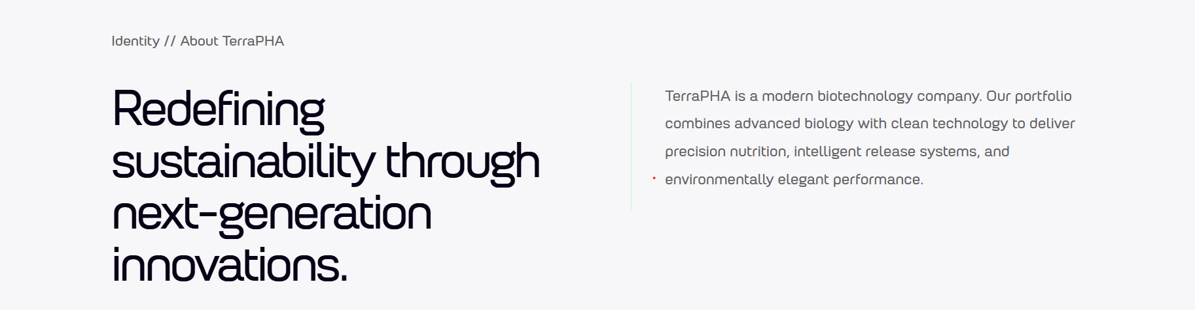

Left side remove identity // about terrapha
Right side change the content to this: TerraOne is a modern biotechnology company. Our portfolio combines advanced biology with clean technology to deliver precision nutrition, intelligent release systems, and environmentally elegant performance.

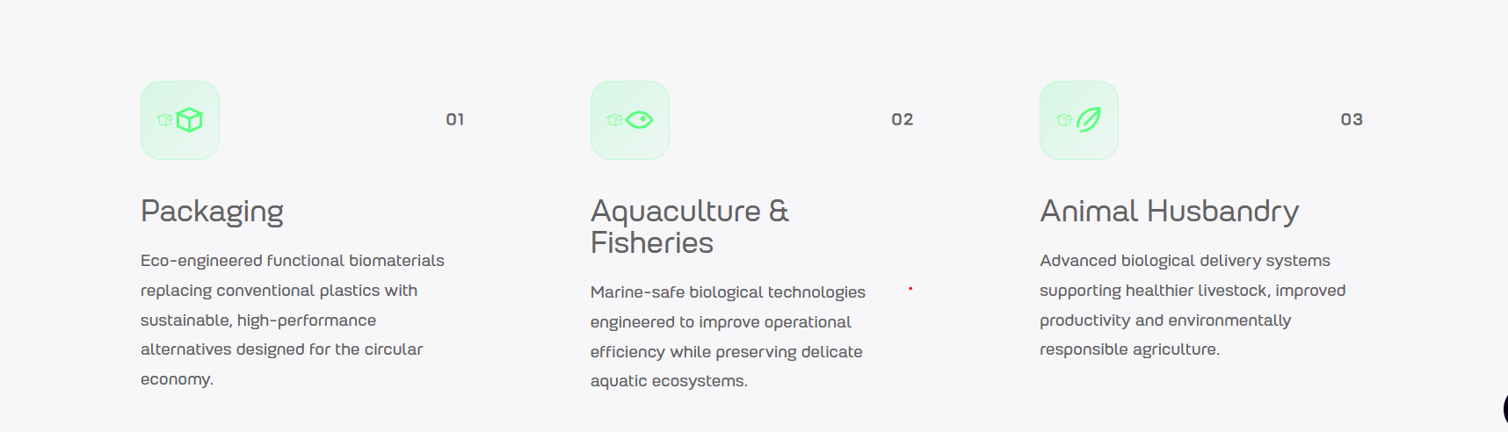
8 sectors: Packaging, Agriculture, Aquaculture, Animal Husbandry, Cosmetics, Biomedical, Pharmaceutical, Waste Water
Aquaculture: Marine-safe biological technologies engineered to improve gut health and yield efficiency while preserving delicate aquatic ecosystems.
Packaging: Protective, high-performance packaging designed to break down in soil, compost and marine environments alike.
Aquaculture: Advanced PHA-based innovations designed to maximise productivity, support healthier aquatic life and sustainable aquaculture.
Animal Husbandry: Innovative technologies supporting animal wellbeing and productivity with a commitment to environmental sustainability.
Agriculture: Soil-safe biopolymers for mulch films, seed coatings and controlled-release systems that degrade naturally in the field.
Cosmetic: Biodegradable microbeads and texturising agents that replace microplastics without compromising performance. Engineered for the same feel, finish and function without the microplastic burden..
Biomedical: Biocompatible solutions enabling the future of medical innovation designed for advance healthcare through sustainable science.
Pharmaceutical: Advanced, sustainable biopolymers engineered for safer, smarter drug delivery systems enabling the future of pharmaceutical technologies
Waste water: Innovative biological solutions aimed for sustainable water management, environmental protection and a healthier planet.
Textile: Biodegradable PHA materials redefining the future of sustainable textiles. Solutions combining performance with environmental responsibility.
Personal Care: Bio-based alternatives delivering high-performance personal care with a lighter environmental footprint where everyday care that doesn't outlive the moment it was made for.

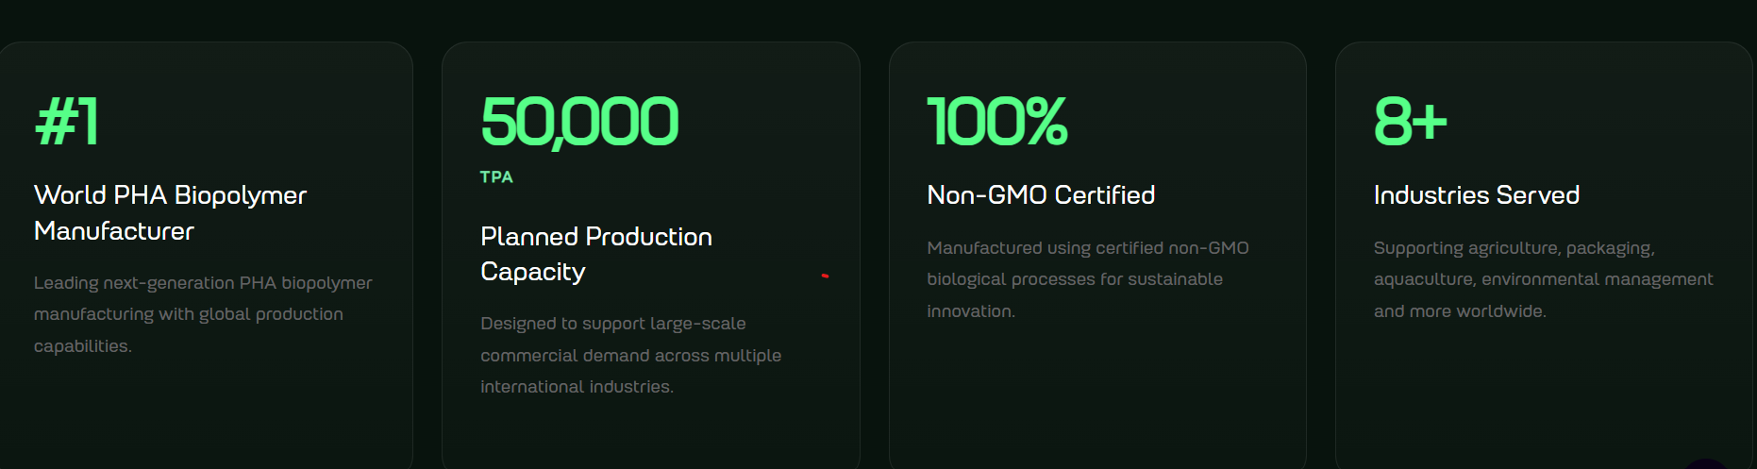
Change this: #1 World First Non-GMO PHA Biopolymer Manufacturer
Change this: 100% Biodegradable
Change: 10+ industries supported

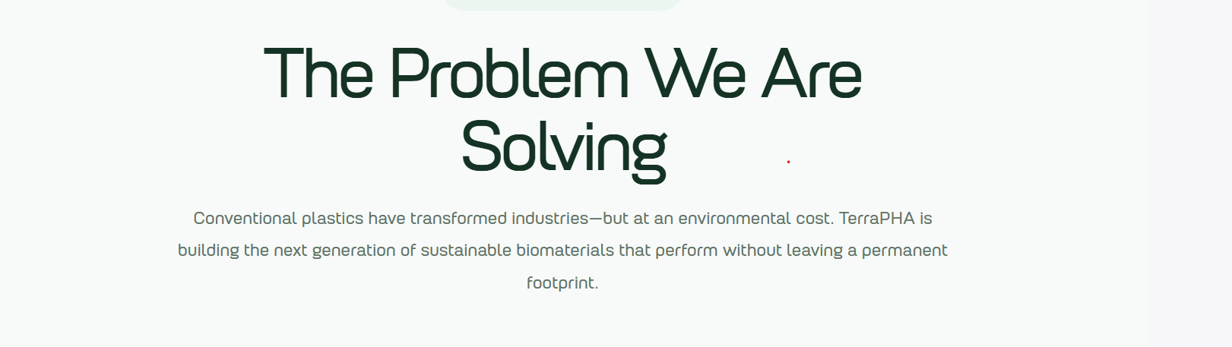
Conventional plastics have transformed industries but at an environmental cost. TerraOne is building the next generation sustainable biomaterials that perform without leaving a permanent footprint.

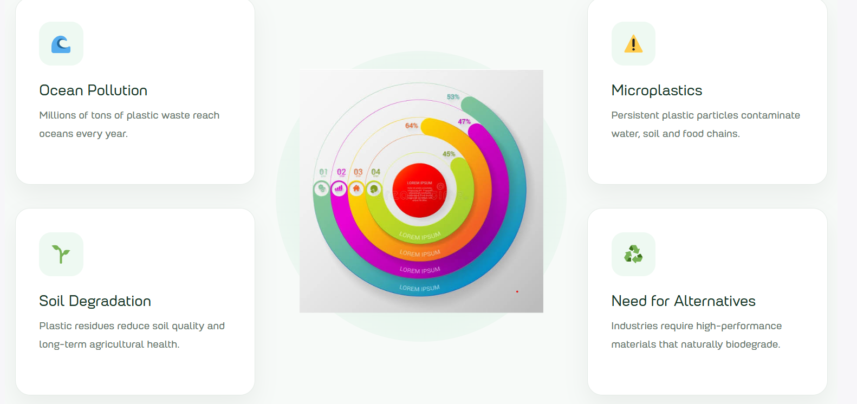
Problem Statements:
- Packaging: Traditional plastic packaging creates long-persisting waste that pollutes land and oceans forever.
- Agricultural: Plastic residue from mulch films and crop covers fragment into the soil, reducing fertility and clogging machinery year after year.
- Aquaculture: Feed additives, cages and nets shed plastics directly into the water systems that fish and shrimp depend on.
- Animal Husbandry: Growing resistance and consumer scrutiny are forcing the sector to look beyond conventional feed inputs as modern livestock farming demands higher productivity while reducing environmental impact.
- Cosmetic Microbeads: Beauty products like exfoliants, fillers, etc often rely on synthetic ingredients and plastic-based materials that wash straight down the drain and could enter into the food chain thereby harming the environment.
- Biomedical Waste: Healthcare requires advanced materials that are both safe for patients and sustainable for the future. Non-degradable implants and devices demand follow-up surgery, raising cost, risk and patient overload.
- Pharmaceutical Delivery Limits: Conventional carriers struggle to release actives at the right rate, and leave synthetic residue behind.
- Waste Water Contamination: Treatment plants are becoming a bottleneck for microplastics as they’re passing them on rather than removing them.
- Textile Shedding: Synthetic fabrics release microfibres with every wash, one of the largest single sources of ocean microplastics.
- Personal Care Disposables: Everyday personal care products often depend on ingredients and packaging that persist in the environment.
Solution Statements:
- Packaging: PHA-based packaging delivers performance that matches the conventional plastic and biodegrade fully in soil, compost and marine conditions.
- Agriculture: Mulch films and controlled-release coatings designed to break down in the field, so none of it needs retrieving and nothing accumulates.
- Aquaculture: Marine-safe biological technologies that enhance gut health, boost yields, and protect aquatic environments.
- Animal Husbandry: Sustainable biological solutions that improve animal health, efficiency, and responsible farming practices.
- Cosmetics: Biodegradable microbeads and texturising agents that replicate the feel and function of microplastics, with a lower environmental footprint.
- Biomedical: Biocompatible, bioresorbable polymers for sutures, scaffolds and devices designed for next-generation medical applications.
- Pharmaceutical: Bioresorbable drug-delivery matrices engineered for controlled release, clean biodegradation and pharmaceutical innovation.
- Waste Water: Biodegradable technologies that improve treatment efficiency while supporting cleaner water systems.
- Textile: Biodegradable PHA materials driving a cleaner, circular future for textiles.
- Personal Care: Everyday essentials made from fully biodegradable materials for high-performance personal care with a lighter environmental footprint.

Grades of PHA
- PHA: PHA (Polyhydroxyalkanoates) are biodegradable polyesters produced by microorganisms as intracellular carbon and energy storage compounds. It fully breaks down in soil and marine environments, making it a genuine alternative to conventional petroleum-based plastics like PLA.
- PBAT: PBAT (Polybutylene Adipate Terephthalate) is a petroleum-derived biodegradable plastic often blended with PLA or starch-based materials to improve flexibility, PBAT compares to PHA in compostability but unlike PHA, it relies on fossil feedstocks rather than microbial fermentation.
- PBS: PBS (Polybutylene Succinate) is a biodegradable polyester made from succinic acid and butanediol, PBS offers PHA-like compostability and decent heat resistance. It has good mechanical properties and is used in packaging, agricultural films, and disposable products.
- PLA: PLA (Polylactic Acid) is a biodegradable thermoplastic polymer derived from fermented plant starches like corn or sugarcane through lactic acid fermentation, PLA is compostable only under industrial conditions. It is widely used in food packaging, disposable utensils, and 3D printing applications due to its biodegradability and good mechanical properties.
- CELLULOSE: The most abundant natural polymer on earth, cellulose forms the structural backbone of plant cell walls and serves as feedstock for bioplastics and packaging films.
- TPS: TPS (Thermoplastic Starch) is a biodegradable plastic made by processing natural starch with plasticizers under heat and pressure, TPS is low-cost and fully compostable but, unlike PHA, it's highly sensitive to moisture and often needs blending with other polymers to hold up structurally.

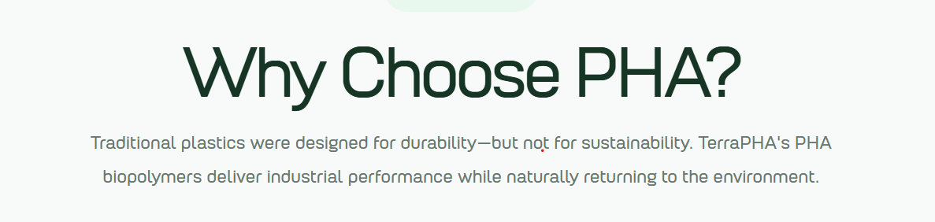
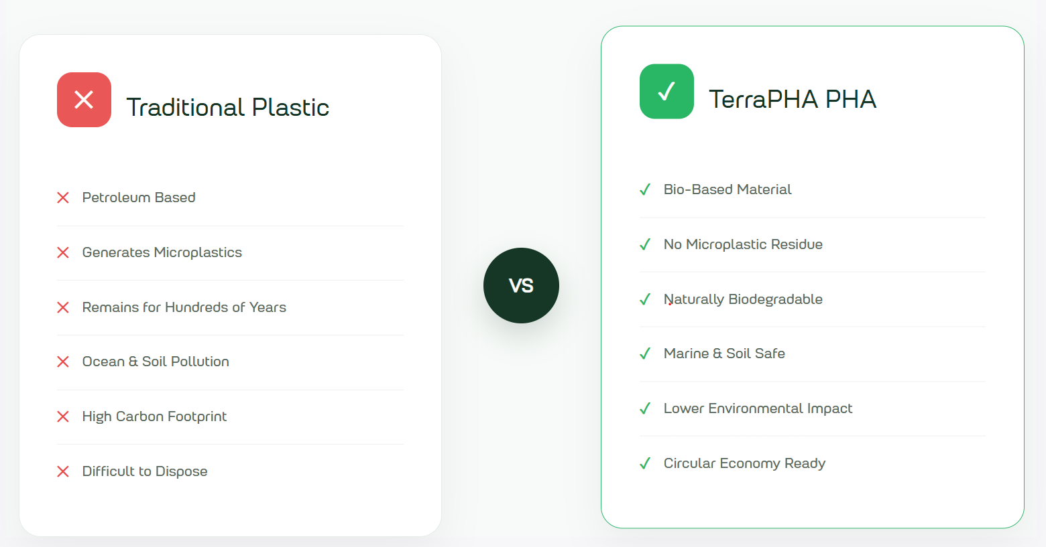

Traditional Plastic:
Conventional plastic is derived from petroleum and engineered to endure, yet the majority of it is discarded within minutes of first use. The consequences are long-lived as it persists in landfill for centuries, fragments into particles too small to recover, and migrates through soil, water and, ultimately it enters the food chain. Only a modest share is ever recycled, and much of what is collected is downcycled once before being discarded permanently. The material was never intended to have an ending, and it does not have one.
Why PHA
PHA is a naturally occurring polymer, generated through fermentation, and the same microorganisms that synthesise it in nature are equally capable of breaking it down. In soil, in compost and in seawater, it degrades fully and leaves no microplastic residue. No specialist facility is required, and no waste stream remains to be managed. In use it performs comparably to conventional plastic, which is precisely the intention of being a reliable material performance, coupled with an end-of-life that resolves itself. TerraOne is the first company in the world to produce PHA entirely without genetically modified organisms.

